Andy Chia – 101111058

1. (a)

**Stem-and-leaf of WEIGHT   N = 50**

|  |  |  |
| --- | --- | --- |
| 2 | 11 | 68 |
| 4 | 12 | 12 |
| 12 | 12 | 55578899 |
| 15 | 13 | 114 |
| (13) | 13 | 5566677778999 |
| 22 | 14 | 00012234 |
| 14 | 14 | 5678999 |
| 7 | 15 | 11 |
| 5 | 15 | 667 |
| 2 | 16 | 12 |

*Leaf Unit = 0.1*

(b) Smallest: 11.6 Largest: 16.2

(c) Average: 13.858

(d) Q1: 13.050 Q3: 14.625

(e) 13.850

1. (a)

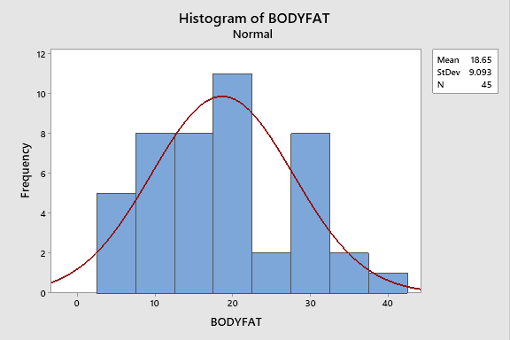

(b) Quantitative

(c) equal

(d) based on the shape of the histogram, the mean and median should be close as it is even and not squeued on both sides

(e) Mean: 18.65 Median: 19.00

Both the mean and the median are close to each other

Sample statistics because it picks out 50 people from a population

(f) Empirical Rule is the best option for this data as the distribution is normal.

1. (a)

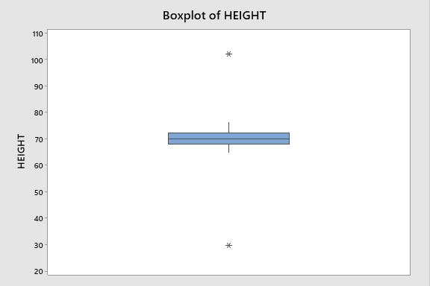

(b) Very skinny

(c) Yes there are outlier: 102.00 and 29.50

(d) Q1: 67.875 Q2: 70 Q3: 72.25

(e) LF = 67.875 – 1.5*4.375 = 61.3125

UF = 72.25 + 1.5*4.375 = 78.8125

(f) no they are not as they are well under and above the fences.